Sandcastle Installation and use guide

# Installation

## Getting the resources

Visit the SHFB (sandcastle help file builder) installation page [here.](https://github.com/EWSoftware/SHFB/releases)

Select and download the SHFBinstaller for the latest release.

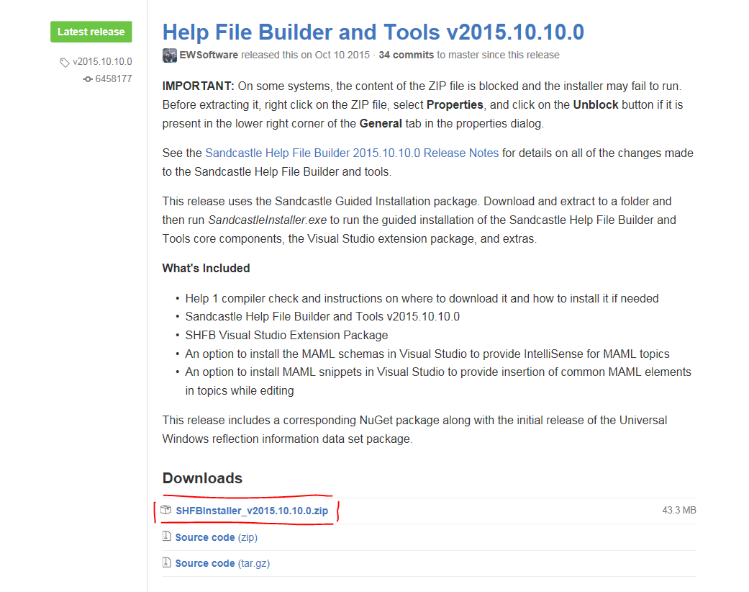

Save and then open the downloaded file.

## Running the installer

Select SandcastleInstaller.exe from the list

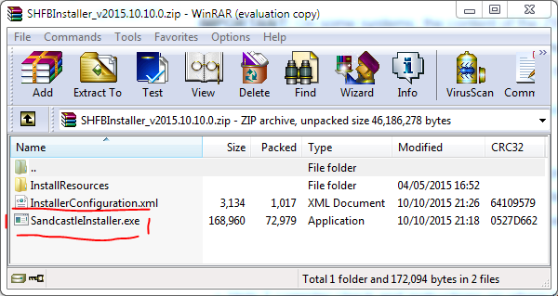

If you get a security warning hit Run.

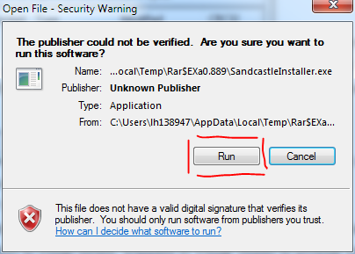

At the welcome page hit next on each page and install any additional software it may prompt you for.

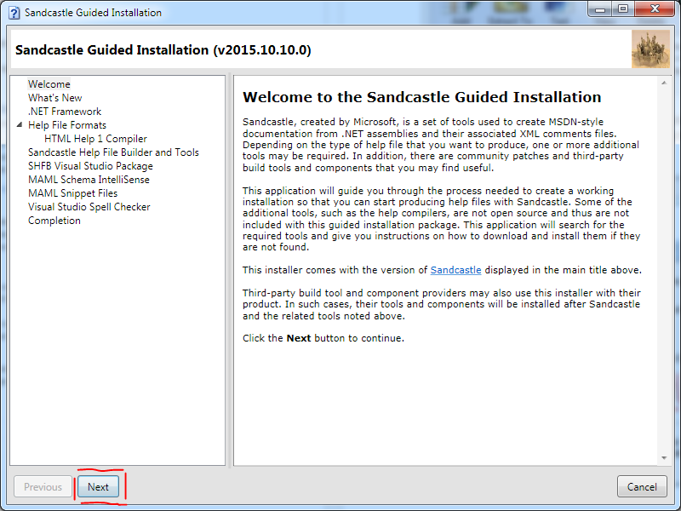

## Installing SHFB

When you reach the “Sandcastle Help File Builder and Tools” page click on “Install SHFB”.

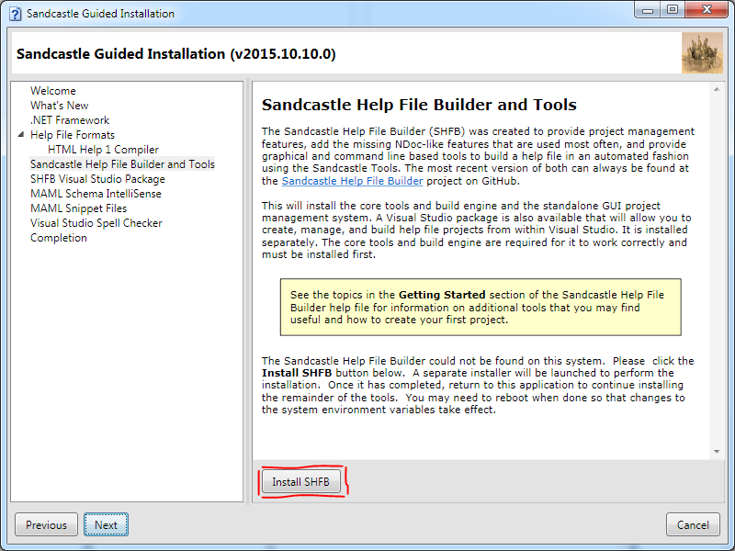

If prompted with a security warning hit run.



Hit next

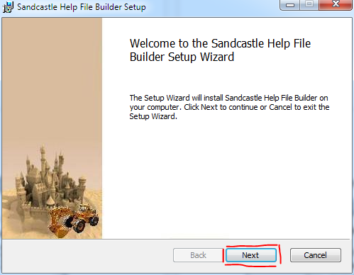

Read and accept the licence agreement

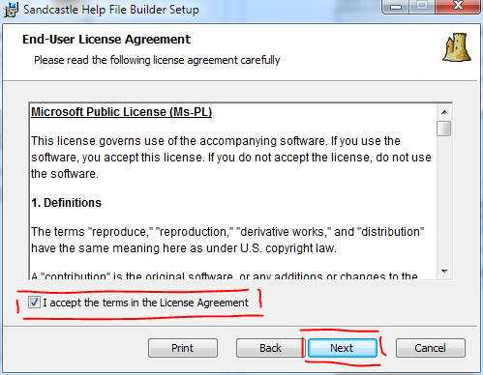

Specify the installation directory if you do not wish to use the default and hit next.

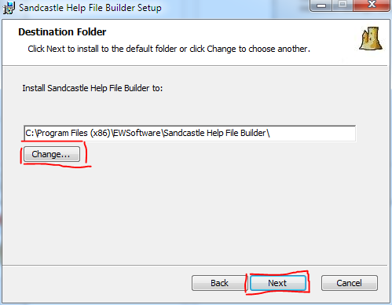

Click install.

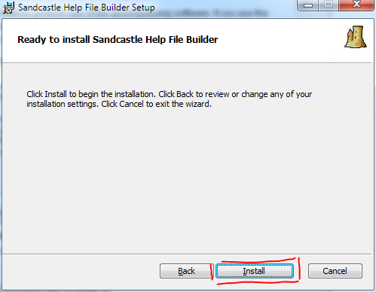

Installation should take around 30s-2mins dependant on pc specs.

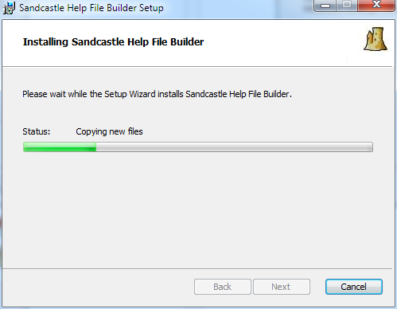

Click finish, SHFB is now installed

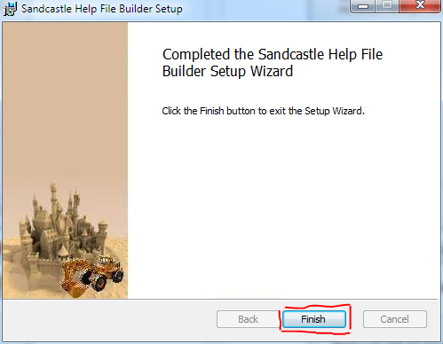

## Additional tools

Go back to the guided installation if it does not open by itself and hit next.

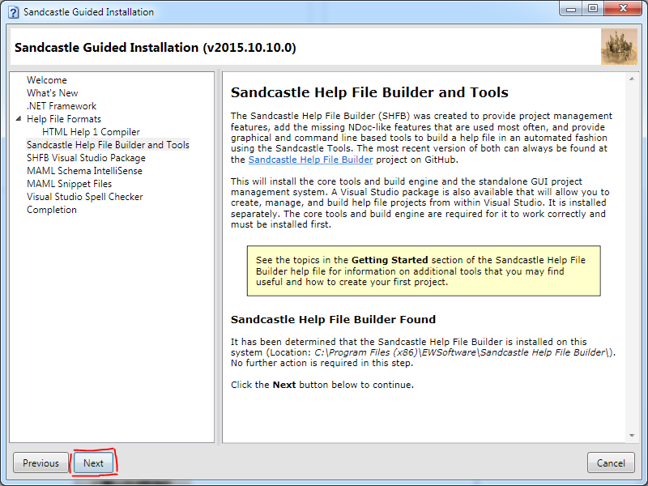

If using visual studio you can install packages to help with visual studio integration.

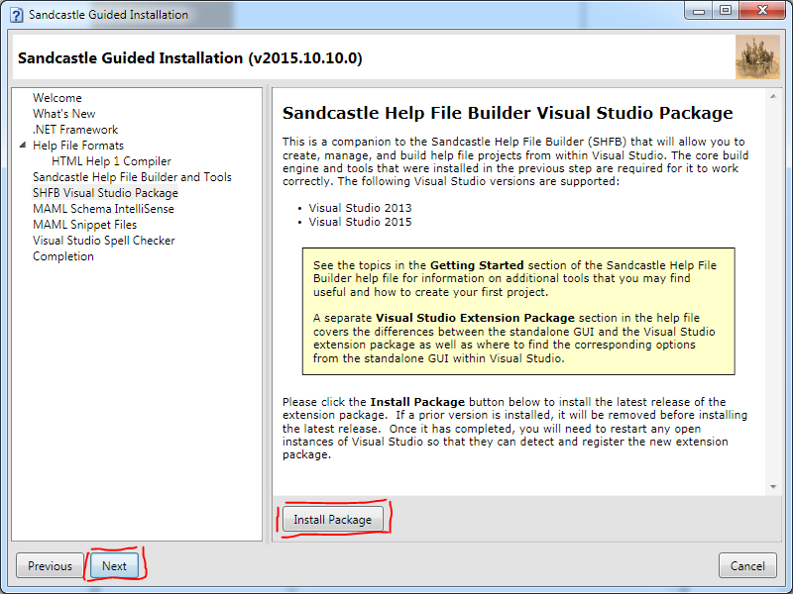

The installation should take 20-40 seconds.

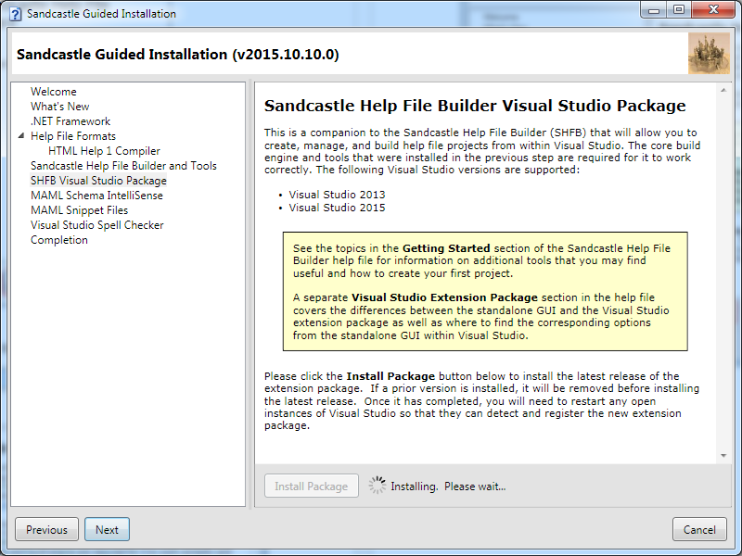

The page will notify you when successfully installed.

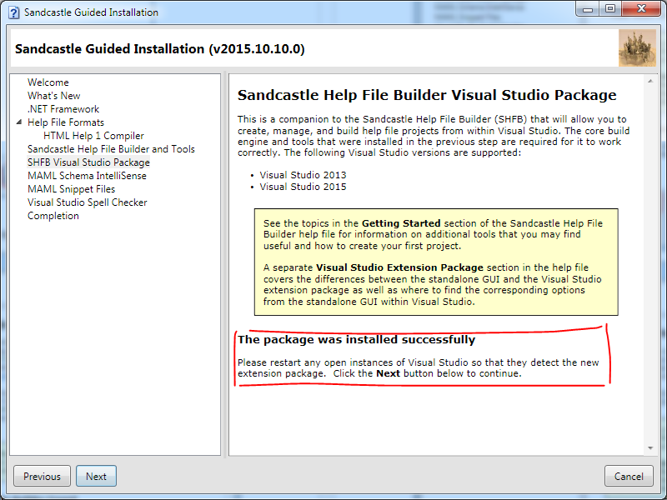

Installing intelligence tools for visual studio will give pointers to ensure code is fully covered by generated documentation. Click Install schemas, after installing hit next.

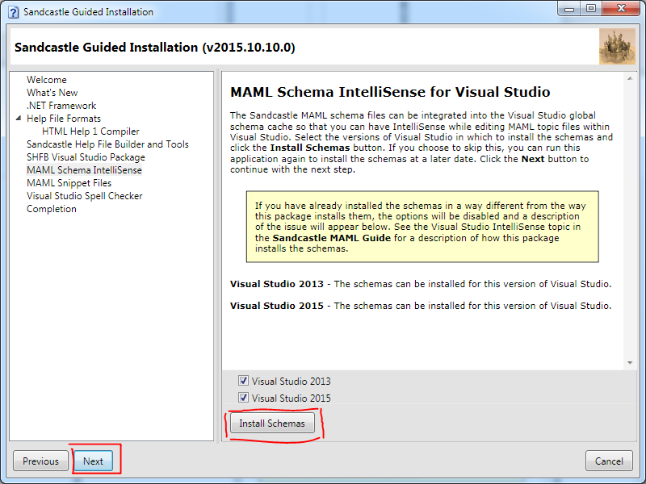

Installing snippets will enable code to have prebuilt documentation put into place to aid in documentation.

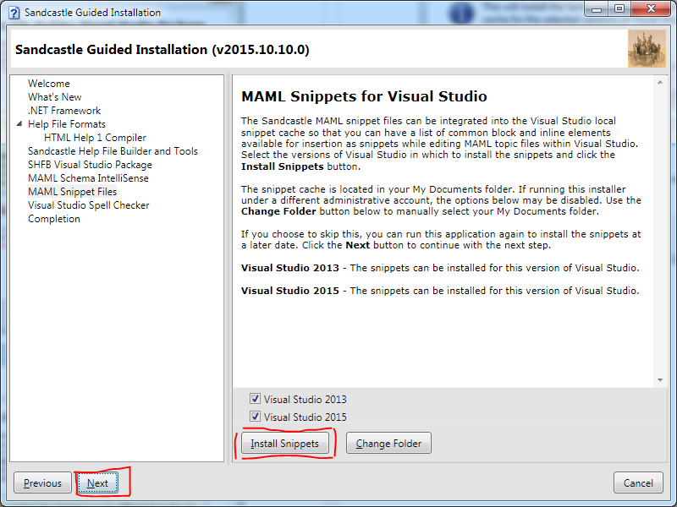

Click next.

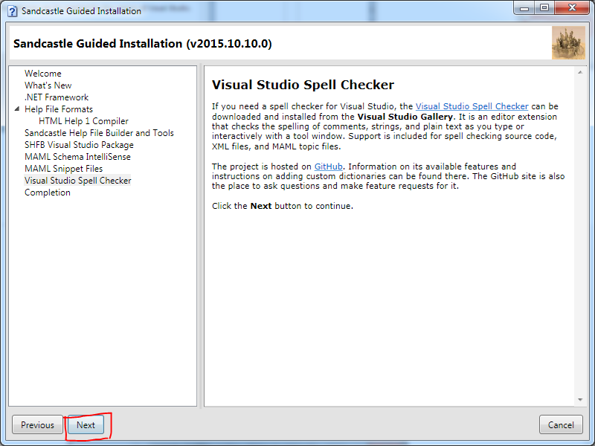

Congratulations you are now ready to use SHFB.

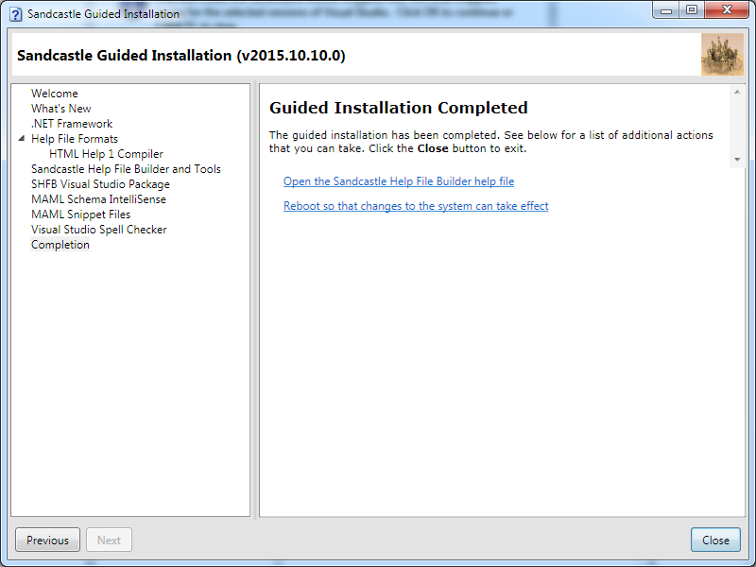

# Updating Adaptive Ads documentation

Open the project file.

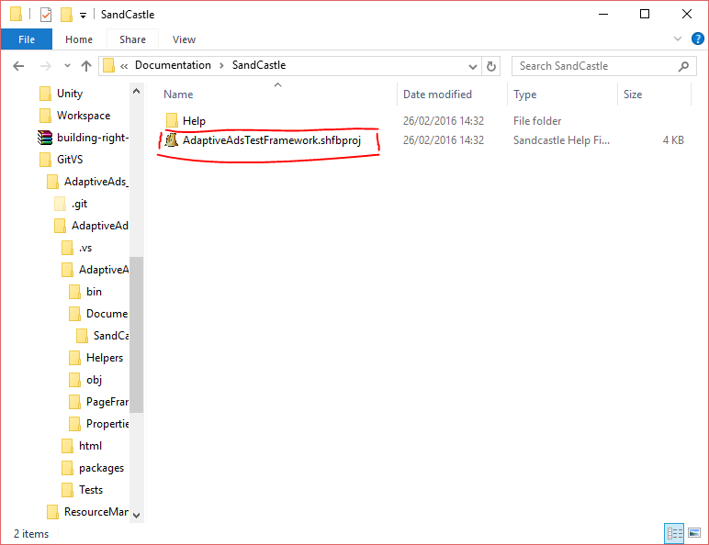

## Updating the documentation details

Select Help File on the left pane and update the version number using the following format. <major version>.<minor version>.<build number> then save the project.

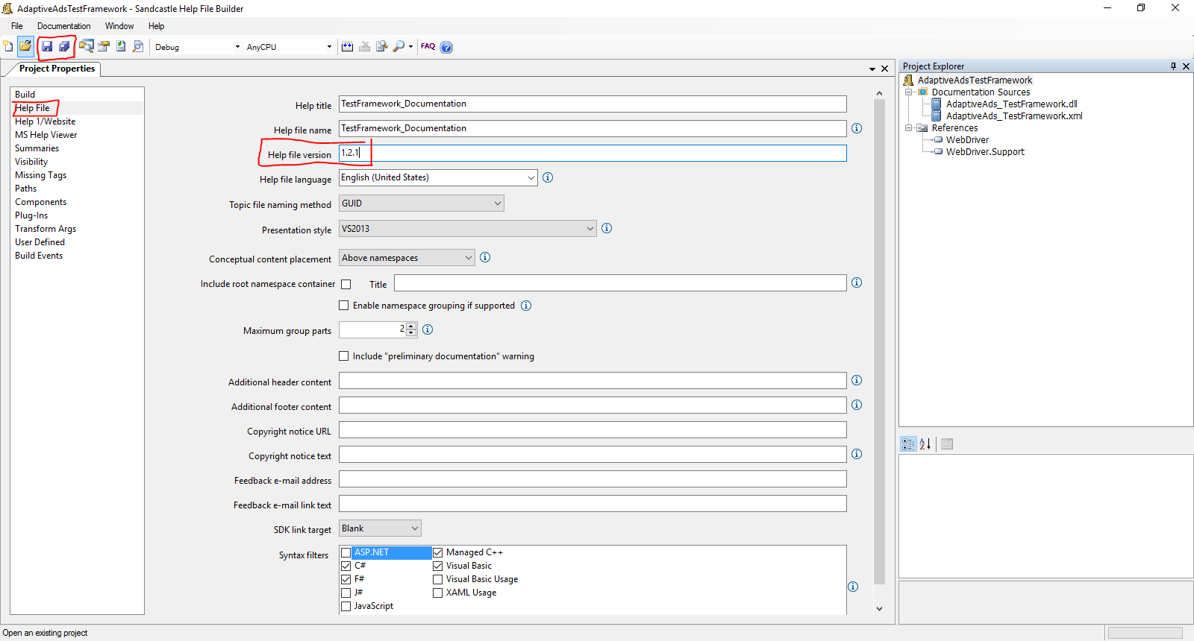

## Building documentation

Click build

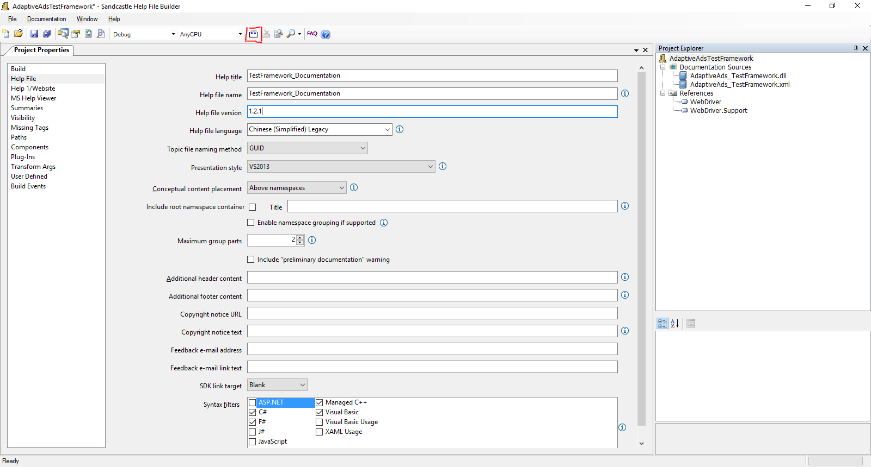

Sandcastle will begin building the documentation

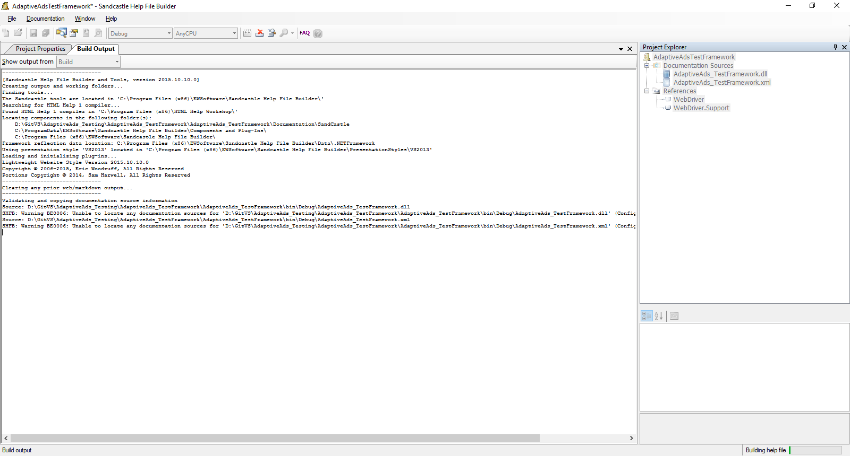

If you get the following error then Sandcastle cannot find the dlls. To rectify this you can do one of two things.

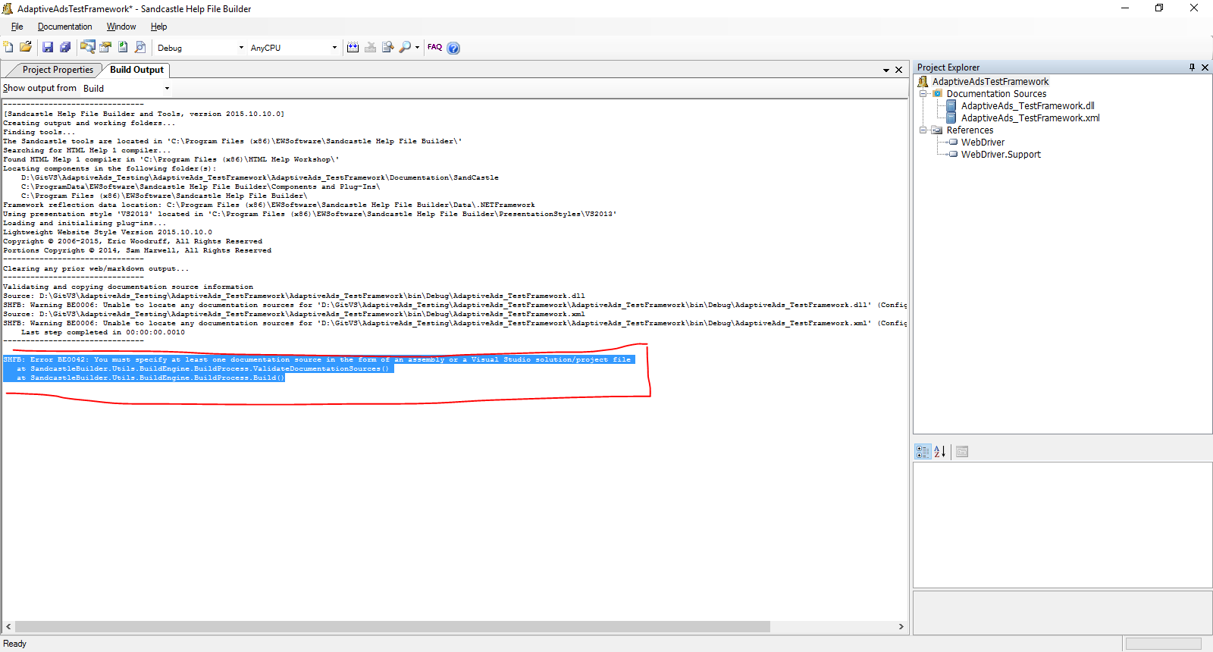

### Error handling Option 1

If you have visual studio installed open the testing project and rebuild the project. This will generate the dlls which the documentation project is looking for.

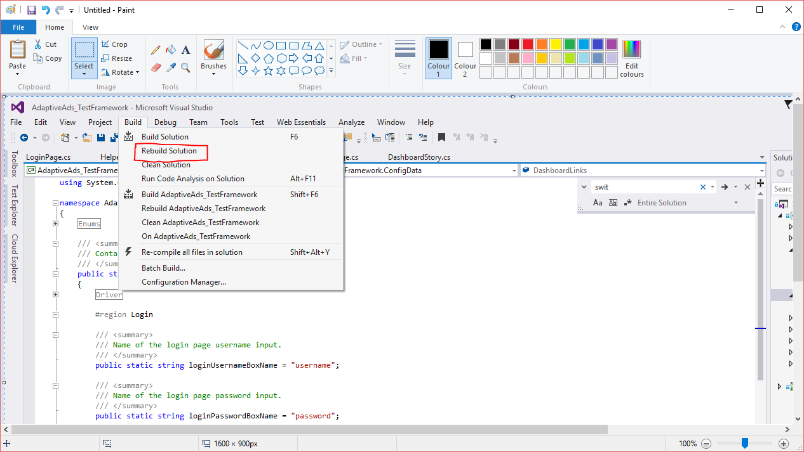

Wait for the build completion notification and then go back to SHFB and retry the documentation build.

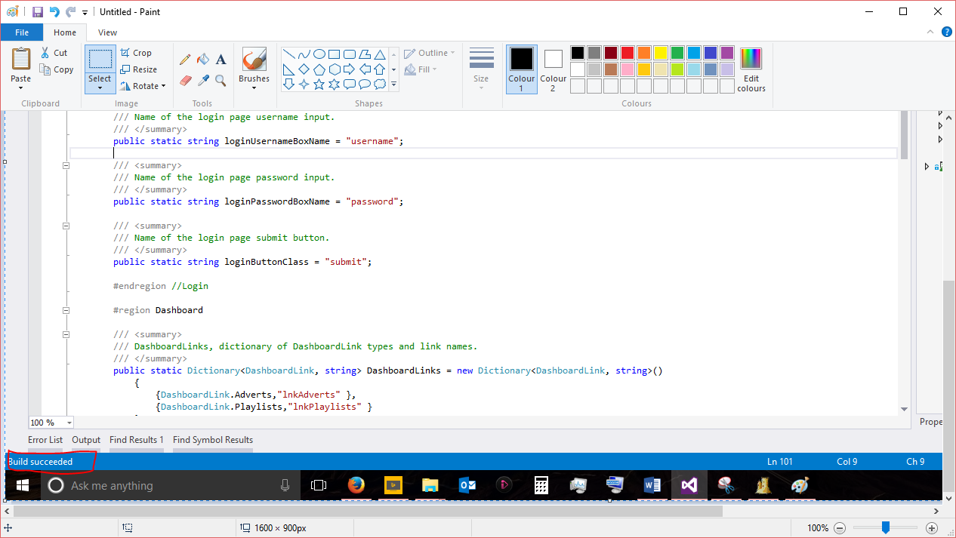

### Error handling Option 2

If you do not have visual studio you will need a copy of the project bin folder and add references manually to the project.

In project explorer remove the dll and xml file as well as both WebDriver references. Then rightclick document sources and select add existing. Navigate to the bin folder and add the projects dll, the xml file should automatically be pulled in, if not add it as well. Then under references click add any other dll’s that are in the bin folder as these are referenced by the project and sandcastle requires them to interrogate the project dll. After this try to rebuild.

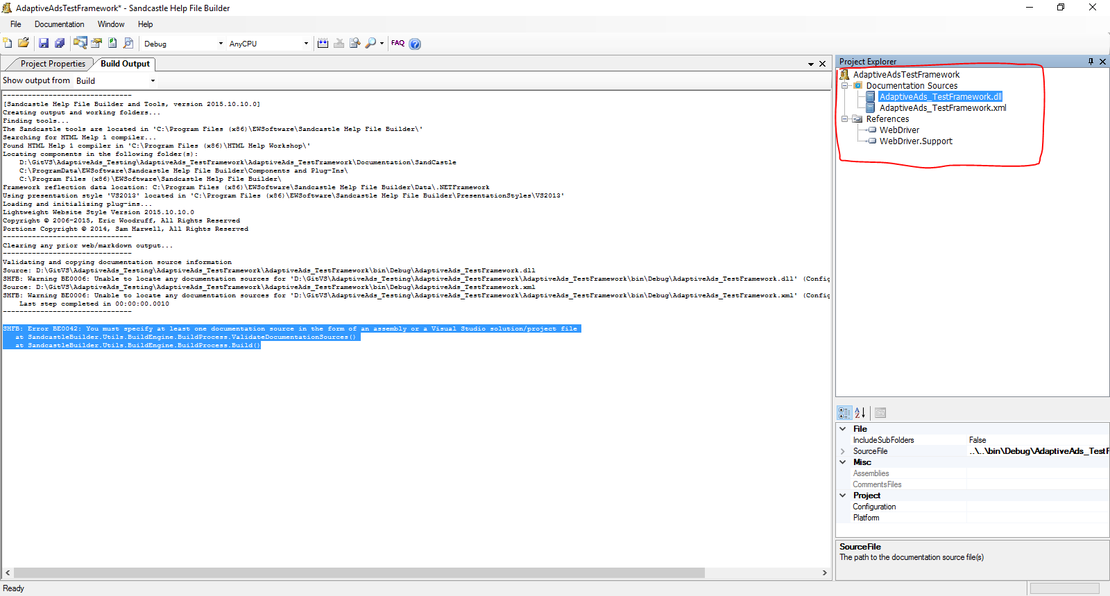

The project will be successfully documented when you get this output.

